­Program 2 / CSC1310

**Magical Creature / monster zoo – linked lists**



# important dates

**Assignment Date:** Friday, September 25, 2020

**Due Date:** Friday, October 9, 2020

# what should this program do?

Create a magical creature (or monster) zoo inventory program that will allow a zookeeper to add magical creatures (either manually or from a file), delete a creature, and display all creatures in the zoo.

The zoo creatures will be organized in a **linked list**.

# files that should be included in your submission

* **Zoo.cpp** – this file will contain your main function that will allow the user to enter, delete, and print creatures. The main function will create the linked list of creatures.
* **Creature.h** – class specification for the Creature class
* **Creature.cpp** – class implementation for the Creature class
* **LinkedList.h** – a Singly-Linked List template class that you create (DO NOT USE THE LIST CLASS PROVIDED IN THE STANDARD TEMPLATE LIBRARY). All the member functions should be defined in this file as well (either inline or below the class declaration).
* **creatureFile**.**txt** – this is the text file that contains creature data in it. You should submit a file with at least five creatures/monsters.

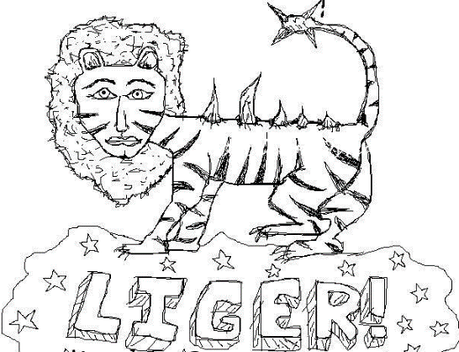

# ExaMple creaturefile.txt

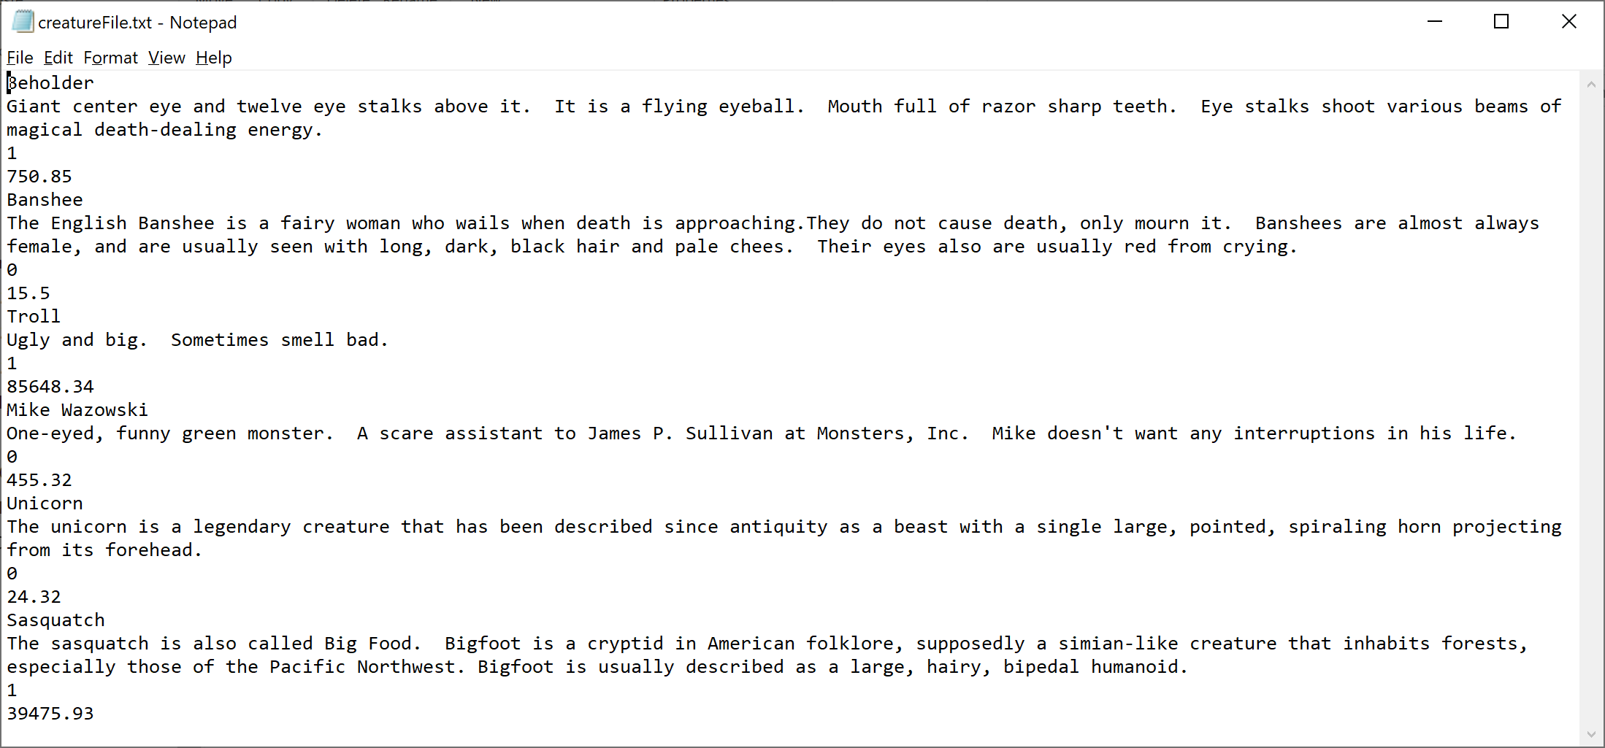

# program specifications (directions on how to write the program)

## linkedlist.h

Create a **template** class (LinkedList.h) that declares a singly-linked list. This template class should be able to create a linked list of any type of object.

**~~LinkedList class should have the following attributes:~~**

* **~~A structure (struct) ADT named ListNode, which defines a node with a value & a pointer to the next ListNode.~~**
* **~~A pointer to a ListNode named head~~**
* **~~A pointer to a ListNode named tail~~**
* **~~An integer named numNodes~~**

**~~LinkedList class should have the following member functions:~~**

* **~~Constructor – should initialize head & tail to point to nothing and initialize numNodes to zero~~**
* **~~Destructor~~** ~~– like a “RemoveAll” function – should deallocate memory for all existing nodes~~
* **~~getLength~~** ~~– should return the number of nodes in the list~~
* **~~getNodeValue~~** ~~– this function accepts a position (integer) as a parameter and then returns the value (object) inside the node at that position~~
* **~~appendNode~~** ~~– this function accepts a value (object) as a parameter. It creates a new node at the end of the list with the sent object inside of it and increments the number of nodes. This function does not return anything.~~
* **~~deleteNode~~** ~~– this function accepts a position (integer) as a parameter, which indicates the position of the node to be deleted. It updates the links of the nodes on either side of this node to be deleted. Then it deletes the node. Then, it decrements the number of nodes.~~

## Creature

Create a class specification (Creature.h) & class implementation (Creature.cpp) file for a class named Creature. The purpose of the Creature class is to allow for creation of a Creature object.

**~~Creature~~****~~should have the following~~****~~attributes~~**~~:~~

* ~~The creature’s name (string)~~
* ~~A description of the creature (string)~~
* ~~The cost (float) of the creature (per month) to care for it (food, grooming, destruction, etc)~~
* ~~A boolean representing whether the creature is dangerous or not (1 means true – it is dangerous and 0 means false, it is not dangerous)~~

**~~Creatures should have the following~~****~~member functions~~**~~:~~

* **~~Constructor~~** ~~– default constructor (doesn’t have to have anything inside it)~~
* **~~Constructor~~** ~~with parameters – string, string, bool, & float – should initialize the creature’s attributes~~
* ~~Accessor functions~~
  + **~~getName~~**
  + **~~getDescription~~**
  + **~~getDangerous~~**
  + **~~getCost~~**
* ~~Mutator functions~~
  + **~~setName~~**
  + **~~setDescription~~**
  + **~~setDangerous~~**
  + **~~setCost~~**
* **~~printCreature~~** ~~– a function to print a single creature’s information to the screen in a nice, easy to read format~~
* **~~printCreatureToFile~~** ~~– a function to print a single creature’s information to the file – unformatted – one piece of information per line. This is so the program would be able to read the creature’s information back later.~~

## zoo.cpp

This is the driver. This file should have a main function and several other functions to organize or help the main function as described below:

* **~~main~~** ~~– This function should create a creature linked list, based on the~~ **~~LinkedList~~** ~~template class you create. Then it should display a menu of four options until the user chooses option 4, which is to end the program. Look at sample output to see the flow of the program.~~ 
  + ~~If user chooses option 1, then a sub-menu should be shown to ask user if they want to enter creatures manually or from file. If manually, then the~~ **~~enterMagicalCreature~~** ~~function should be called, sending the address of the creatureList to this function. If from a file, then the~~ **~~enterMagicalCreatureFromFile~~** ~~function should be called, sending the address of the creature list to this function.~~
  + ~~If user chooses option 2, then the~~ **~~deleteCreature~~** ~~function should be called, sending the address of the creature list to this function.~~
  + ~~If user choses option 3, then the~~ **~~printCreatures~~** ~~function should be called, sending the address of the creature list to this function.~~
  + ~~If user chooses option 4, then the program should ask the user if they want to save their creature list to a file. If user chooses yes, then call the~~ **~~saveCreaturesToFile~~** ~~function, sending the creature list to this function. Print “GOODBYE!” before the program ends.~~
* **enterMagicalCreature** – this function should ask the user for the creature’s name, description, if it is dangerous, and the cost per month to care fo rhte creature. Then it should create a new creature object with this data. Then, it should append the creature object to the linked creature list. Then it should print a confirmation that the creature (print creature’s name) has been added to the zoo. The function should then ask the user if they want to add more creatures. If they answer yes, then repeat this process. Otherwise, the function should end and it doesn’t return any data.
* **enterMagicalCreatureFromFile** – this function should ask the user for the name of the file they want to read from. Then, if the file is able to be opened (print a message if can’t be opened) then read the creature data from the file (one at a time) with a loop and after reading in one creature, create a new creature object with this data, then append the creature to the creature linked list. After reading all the creatures from the file & adding them to the linked list, print how many creatures FROM THE FILE were added to the zoo. This may or may not be the current number of creatures in the linked list! This function does not return any data.
* **deleteCreature** – this function should first print a numbered list of the names of all the creatures in the linked list. Then ask the user which creature number they want to delete. Then the creature should be removed from the linked list. A confirmation should be printed out that the creature was removed. This function does not return anything.
* **printCreatures** – this function should print “THERE ARE NO CREATURES AT YOUR ZOO!” if there are no creatures in the linked list. If there are creatures in the linked list then it should print each creature’s detail in the list. This function does not return anything.
* **saveCreaturesToFile** – this function should either print “THERE ARE NO CREATURES AT YOUR ZOO!” if there are no creatures in the linked list. If there are creatures in the linked list then it should ask the user for the filename that they wish to use to save the creatures and then use a loop to get a creature from each node, and then call this creature’s printCreatureToFile function, sending the filename to the function.

# Readability of output & code documentation

* Make sure that your output looks similar to my sample output (below). When I run your program, it should be extremely readable and user-friendly.
* Follow good programming practice in naming your variables and using indentions.
* **For this program, don’t worry about comments except put your NAME at the top of all files!!!**

# What to turn in

Zip ALL the files required to compile & run the program in a single zipped file named whatever you want. Then, upload this zip file to the assignment folder in ilearn. **I will remove one point if you turn in unzipped files. Programs that do not include all the files listed in the “FILES” section above will not be graded.**

# Sample Output

**What would you like to do?**

**1. Enter Magical Creature**

**2. Delete a Magical Creature.**

**3. List/Print Creatures.**

**4. End Program.**

**Enter 1, 2, 3, or 4.**

**CHOICE: 9**

**Your choice was invalid. Choose a number 1 through 4.**

**CHOICE: 3**

**------------------------------------------------------------------------**

**THERE ARE NO CREATURES AT YOUR ZOO!**

**What would you like to do?**

**1. Enter Magical Creature**

**2. Delete a Magical Creature.**

**3. List/Print Creatures.**

**4. End Program.**

**Enter 1, 2, 3, or 4.**

**CHOICE: 1**

**Do you want to enter the creature(s)**

**1. Manually?**

**2. From a file?**

**ENTER 1 or 2: 2**

**What is the name of the file you want to read from?**

**FILENAME: creatureFile.txt**

**6 creatures from creatureFile.txt have been added to the zoo.**

**What would you like to do?**

**1. Enter Magical Creature**

**2. Delete a Magical Creature.**

**3. List/Print Creatures.**

**4. End Program.**

**Enter 1, 2, 3, or 4.**

**CHOICE: 3**

**------------------------------------------------------------------------**

**CREATURE 1:**

**Name: Beholder**

**Description:**

**Giant center eye and twelve eye stalks above it. It is a flying**

**eyeball. Mouth full of razor sharp teeth. Eye stalks shoot**

**various beams of magical death-dealing energy.**

**Dangerous? yes**

**Cost per Month to Care for Creature: $ 750.85**

**------------------------------------------------------------------------**

**CREATURE 2:**

**Name: Banshee**

**Description:**

**The English Banshee is a fairy woman who wails when death is**

**approaching. They do not cause death, only mourn it. Banshees**

**are almost always female, and are usually seen with long,**

**dark, black hair and pale chees. Their eyes also are usually**

**red from crying.**

**Dangerous? no**

**Cost per Month to Care for Creature: $ 15.50**

**------------------------------------------------------------------------**

**CREATURE 3:**

**Name: Troll**

**Description:**

**Ugly and big. Sometimes smell bad.**

**Dangerous? yes**

**Cost per Month to Care for Creature: $ 85648.34**

**------------------------------------------------------------------------**

**CREATURE 4:**

**Name: Mike Wazowski**

**Description:**

**One-eyed, funny green monster. A scare assistant to James P.**

**Sullivan at Monsters, Inc. Mike doesn't want any interruptions**

**in his life.**

**Dangerous? no**

**Cost per Month to Care for Creature: $ 455.32**

**------------------------------------------------------------------------**

**CREATURE 5:**

**Name: Unicorn**

**Description:**

**The unicorn is a legendary creature that has been described since**

**antiquity as a beast with a single large, pointed, spiraling**

**horn projecting from its forehead.**

**Dangerous? no**

**Cost per Month to Care for Creature: $ 24.32**

**------------------------------------------------------------------------**

**CREATURE 6:**

**Name: Sasquatch**

**Description:**

**The sasquatch is also called Big Food. Bigfoot is a cryptid**

**in American folklore, supposedly a simian-like creature that**

**inhabits forests, especially those of the Pacific Northwest.**

**Bigfoot is usually described as a large, hairy, bipedal humanoid.**

**Dangerous? yes**

**Cost per Month to Care for Creature: $ 39475.93**

**What would you like to do?**

**1. Enter Magical Creature**

**2. Delete a Magical Creature.**

**3. List/Print Creatures.**

**4. End Program.**

**Enter 1, 2, 3, or 4.**

**CHOICE: 1**

**Do you want to enter the creature(s)**

**1. Manually?**

**2. From a file?**

**ENTER 1 or 2: 1**

**NAME: Chupacabra**

**DESCRIPTION: The name comes from the Spanish chupar which means to suck and cabra means goat. It was named in relation to its first alleged victims - goats - found drained of all of their blood.**

**IS IT A DANGEROUS CREATURE? (y or n): y**

**COST PER MONTH TO CARE FOR CREATURE: 39.2**

**The Chupacabra has been added to the zoo.**

**Want to add more creatures? (y or n) y**

**NAME: Manticore**

**DESCRIPTION: This bizarre monster is reputed to have the body of a lion and the head of a man, porcupine quills, and the tail (or sting) of a scorpion.**

**IS IT A DANGEROUS CREATURE? (y or n): n**

**COST PER MONTH TO CARE FOR CREATURE: 984.56**

**The Manticore has been added to the zoo.**

**Want to add more creatures? (y or n) n**

**What would you like to do?**

**1. Enter Magical Creature**

**2. Delete a Magical Creature.**

**3. List/Print Creatures.**

**4. End Program.**

**Enter 1, 2, 3, or 4.**

**CHOICE: 3**

**------------------------------------------------------------------------**

**CREATURE 1:**

**Name: Beholder**

**Description:**

**Giant center eye and twelve eye stalks above it. It is a flying**

**eyeball. Mouth full of razor sharp teeth. Eye stalks shoot**

**various beams of magical death-dealing energy.**

**Dangerous? yes**

**Cost per Month to Care for Creature: $ 750.85**

**------------------------------------------------------------------------**

**CREATURE 2:**

**Name: Banshee**

**Description:**

**The English Banshee is a fairy woman who wails when death is**

**approaching. They do not cause death, only mourn it. Banshees**

**are almost always female, and are usually seen with long,**

**dark, black hair and pale chees. Their eyes also are usually**

**red from crying.**

**Dangerous? no**

**Cost per Month to Care for Creature: $ 15.50**

**------------------------------------------------------------------------**

**CREATURE 3:**

**Name: Troll**

**Description:**

**Ugly and big. Sometimes smell bad.**

**Dangerous? yes**

**Cost per Month to Care for Creature: $ 85648.34**

**------------------------------------------------------------------------**

**CREATURE 4:**

**Name: Mike Wazowski**

**Description:**

**One-eyed, funny green monster. A scare assistant to James P.**

**Sullivan at Monsters, Inc. Mike doesn't want any interruptions**

**in his life.**

**Dangerous? no**

**Cost per Month to Care for Creature: $ 455.32**

**------------------------------------------------------------------------**

**CREATURE 5:**

**Name: Unicorn**

**Description:**

**The unicorn is a legendary creature that has been described since**

**antiquity as a beast with a single large, pointed, spiraling**

**horn projecting from its forehead.**

**Dangerous? no**

**Cost per Month to Care for Creature: $ 24.32**

**------------------------------------------------------------------------**

**CREATURE 6:**

**Name: Sasquatch**

**Description:**

**The sasquatch is also called Big Food. Bigfoot is a cryptid**

**in American folklore, supposedly a simian-like creature that**

**inhabits forests, especially those of the Pacific Northwest.**

**Bigfoot is usually described as a large, hairy, bipedal humanoid.**

**Dangerous? yes**

**Cost per Month to Care for Creature: $ 39475.93**

**------------------------------------------------------------------------**

**CREATURE 7:**

**Name: Chupacabra**

**Description:**

**The name comes from the Spanish chupar which means to suck and**

**cabra means goat. It was named in relation to its first alleged**

**victims - goats - found drained of all of their blood.**

**Dangerous? yes**

**Cost per Month to Care for Creature: $ 39.20**

**------------------------------------------------------------------------**

**CREATURE 8:**

**Name: Manticore**

**Description:**

**This bizarre monster is reputed to have the body of a lion and**

**the head of a man, porcupine quills, and the tail (or sting)**

**of a scorpion.**

**Dangerous? no**

**Cost per Month to Care for Creature: $ 984.56**

**What would you like to do?**

**1. Enter Magical Creature**

**2. Delete a Magical Creature.**

**3. List/Print Creatures.**

**4. End Program.**

**Enter 1, 2, 3, or 4.**

**CHOICE: 2**

**The following is a list of all the creatures you take care of:**

**0) Beholder**

**1) Banshee**

**2) Troll**

**3) Mike Wazowski**

**4) Unicorn**

**5) Sasquatch**

**6) Chupacabra**

**7) Manticore**

**What creature do you wish to remove?**

**CREATURE NUMBER: 3**

**You have removed the creature.**

**What would you like to do?**

**1. Enter Magical Creature**

**2. Delete a Magical Creature.**

**3. List/Print Creatures.**

**4. End Program.**

**Enter 1, 2, 3, or 4.**

**CHOICE: 3**

**------------------------------------------------------------------------**

**CREATURE 1:**

**Name: Beholder**

**Description:**

**Giant center eye and twelve eye stalks above it. It is a flying**

**eyeball. Mouth full of razor sharp teeth. Eye stalks shoot**

**various beams of magical death-dealing energy.**

**Dangerous? yes**

**Cost per Month to Care for Creature: $ 750.85**

**------------------------------------------------------------------------**

**CREATURE 2:**

**Name: Banshee**

**Description:**

**The English Banshee is a fairy woman who wails when death is**

**approaching. They do not cause death, only mourn it. Banshees**

**are almost always female, and are usually seen with long,**

**dark, black hair and pale chees. Their eyes also are usually**

**red from crying.**

**Dangerous? no**

**Cost per Month to Care for Creature: $ 15.50**

**------------------------------------------------------------------------**

**CREATURE 3:**

**Name: Troll**

**Description:**

**Ugly and big. Sometimes smell bad.**

**Dangerous? yes**

**Cost per Month to Care for Creature: $ 85648.34**

**------------------------------------------------------------------------**

**CREATURE 4:**

**Name: Unicorn**

**Description:**

**The unicorn is a legendary creature that has been described since**

**antiquity as a beast with a single large, pointed, spiraling**

**horn projecting from its forehead.**

**Dangerous? no**

**Cost per Month to Care for Creature: $ 24.32**

**------------------------------------------------------------------------**

**CREATURE 5:**

**Name: Sasquatch**

**Description:**

**The sasquatch is also called Big Food. Bigfoot is a cryptid**

**in American folklore, supposedly a simian-like creature that**

**inhabits forests, especially those of the Pacific Northwest.**

**Bigfoot is usually described as a large, hairy, bipedal humanoid.**

**Dangerous? yes**

**Cost per Month to Care for Creature: $ 39475.93**

**------------------------------------------------------------------------**

**CREATURE 6:**

**Name: Chupacabra**

**Description:**

**The name comes from the Spanish chupar which means to suck and**

**cabra means goat. It was named in relation to its first alleged**

**victims - goats - found drained of all of their blood.**

**Dangerous? yes**

**Cost per Month to Care for Creature: $ 39.20**

**------------------------------------------------------------------------**

**CREATURE 7:**

**Name: Manticore**

**Description:**

**This bizarre monster is reputed to have the body of a lion and**

**the head of a man, porcupine quills, and the tail (or sting)**

**of a scorpion.**

**Dangerous? no**

**Cost per Month to Care for Creature: $ 984.56**

**What would you like to do?**

**1. Enter Magical Creature**

**2. Delete a Magical Creature.**

**3. List/Print Creatures.**

**4. End Program.**

**Enter 1, 2, 3, or 4.**

**CHOICE: 4**

**Would you like to save your creature list to a file? (y or n) y**

**What do you want the filename to be?**

**FILENAME: newCreatureFile.txt**

**Beholder was printed to newCreatureFile.txt**

**Banshee was printed to newCreatureFile.txt**

**Troll was printed to newCreatureFile.txt**

**Unicorn was printed to newCreatureFile.txt**

**Sasquatch was printed to newCreatureFile.txt**

**Chupacabra was printed to newCreatureFile.txt**

**Manticore was printed to newCreatureFile.txt**

**GOODBYE!**